Ideation Phase
Empathize & Discover

Date | 18 Feb 2026
Team ID | LTVIP2026TMIDS74685
Project Name | Visualizing Housing Market Trends: An Analysis of Sale  Prices and Features using Tableau
Maximum Marks | 4 Marks

Empathy Map Canvas:
An empathy map is a simple, easy-to-digest visual that captures knowledge about a user’s behaviours and attitudes.

It is a useful tool to helps teams better understand their users.
Creating an effective solution requires understanding the true problem and the person who is experiencing it. The exercise of creating the map helps participants consider things from the user’s perspective along with his or her goals and challenges.
Example:

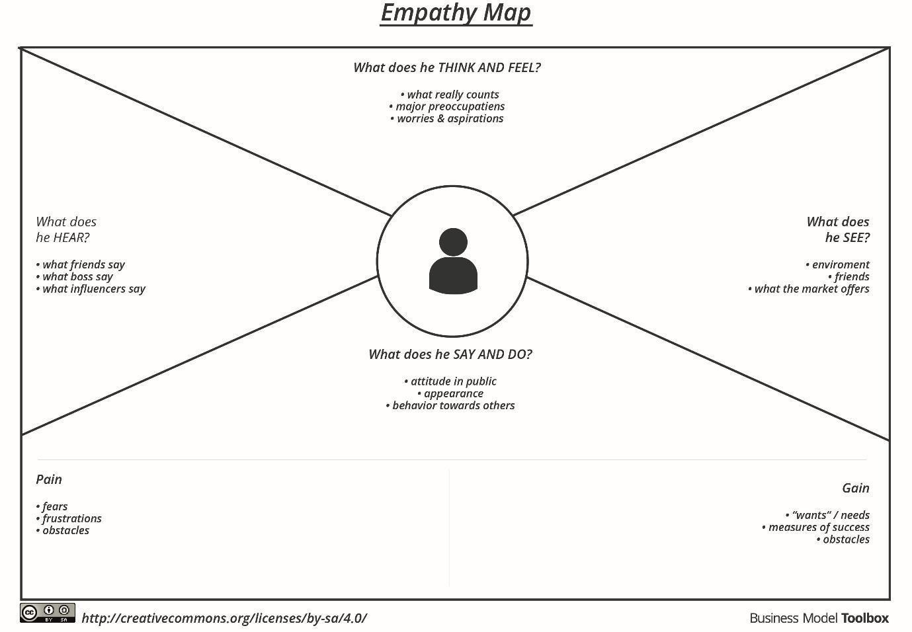

Reference: https://www.mural.co/templates/empathy-map-canvas
Example: Home trends and Price Analysis

Users see property listings, market reports, graphs, maps, and online tools that show housing prices and trends. They often deal with confusing or inconsistent data and rely on visual comparisons to understand the market and make decisions
